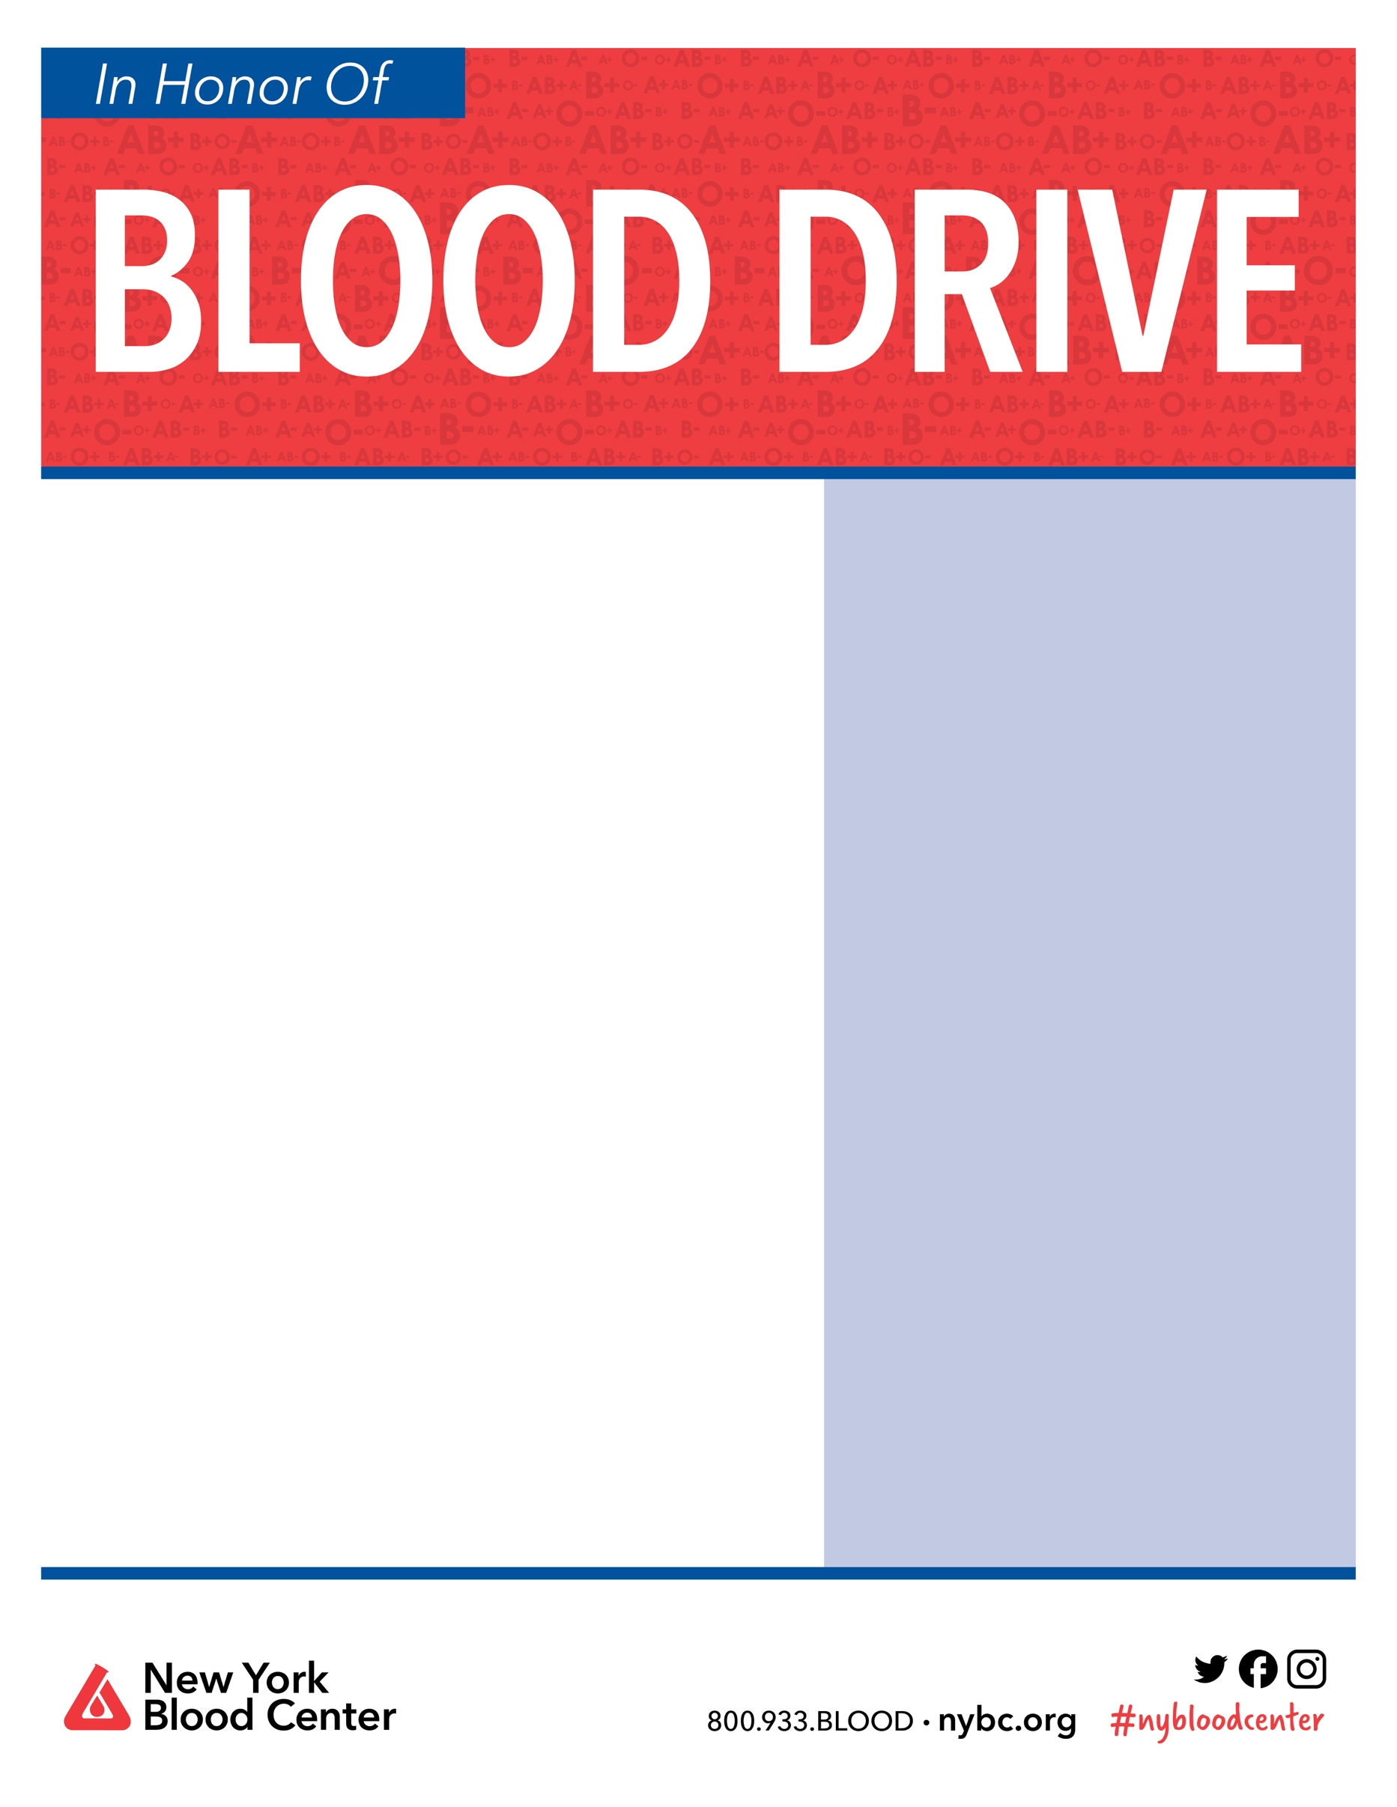

**Sunday August 22**

**9:00am-3:00pm**

**South Branch Emergency Services**

**formally Clinton First Aid and Rescue Squad**

**Old Route 22 Clinton**

**Appointments preferred**

**For an appointment go to**

<https://nybc.org/newjerseydrive>

**sponsor code 12443**

**or call 800-933-2566**

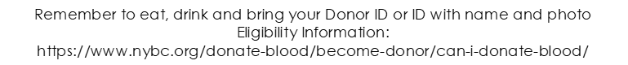

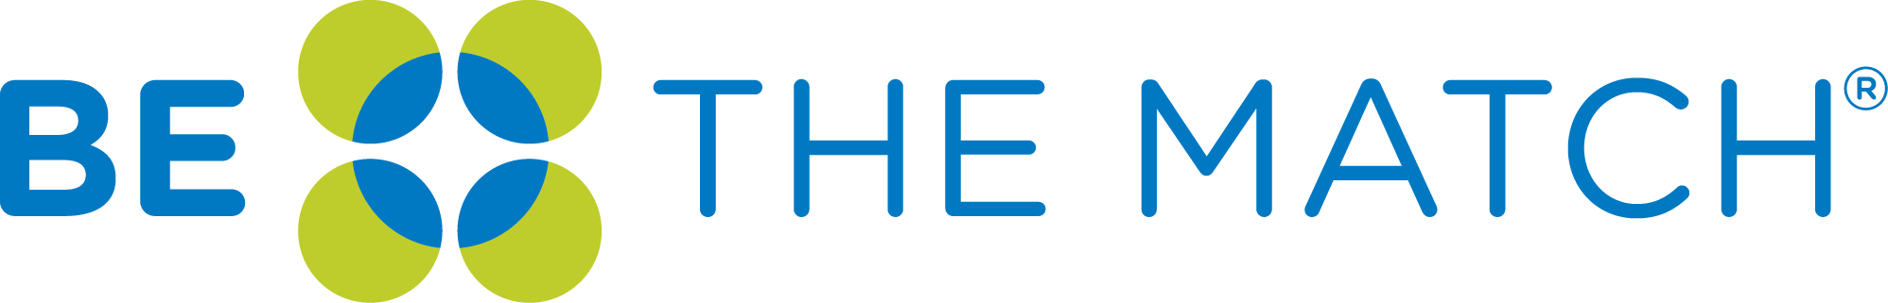

To join the Be the Match registry, you must:

* Be between the ages of 18 – 44
* Be in general good health
* Be committed to donating to anyone in need

**Join Today**:

[**https://my.bethematch.org/Ayden**](https://my.bethematch.org/Ayden)

**Text AYDEN to 61474 or scan the QR Code above**

*Ayden is a handsome and kind 4-year-old who was recently diagnosed with (ALL) Acute Lymphoblastic Leukemia. Despite receiving an aggressive chemotherapy and blood transfusions, he remains strong with a smile on his face. His parents, both, NYC first responders, and his older sister, hold his hand as he begins this road of battling and defeating cancer!*

*Come donate blood and join the Be The Match registry to help Ayden or patients like him.*

**Ayden Paredes**

To honor Person we want to give back. Please join us in celebrating Person by donating blood.